**COMP 201 Coursework 2**

Yifan Xu

Student Number : 201377026

14, Dec , 2018

**Contents**

Task 1……………………………………………………….2

Task 2……………………………………………………….5

Task 3……………………………………………………….7

Task 4……………………………………………………….9

**TASK 1. (25%)** Given the following informal specification, **identify good candidates** for classes and attributes, and **identify things that are outside** of the problem domain. Also identify **all potential inheritance relationships**. You should ensure that data is **NOT** duplicated across classes even if a user places multiple bookings. Use the noun identification method of class elicitation for the first pass. Please show your working. For this task produce a list of candidate classes and attributes, then eliminate redundant classes. For your submission please produce a class diagram containing all the classes, their attributes and showing all relevant associations including inheritance and aggregation or composition.

*Your customer is a travel agency that wants a reservation system that will run on the Internet. This reservation system will allow clients to keep track of all their travel reservations for airlines, hotel, travel insurance and rental cars. The client must enter the names of all his/her traveling companions, but all reservations will be under the name of the primary client. The system needs to make it easy for a client to have multiple reservations. All reservations will include a booking number as well as their names, passport numbers and dates of birth of all the travelers involved in the reservation. The system should also have an address for the primary client.*

*Airline reservations will include the airline, flight number, class of seat and travel dates and times. For each flight per passenger there will be a unique reservation.*

*Hotel reservations will include the type (twin, single, double) and of rooms and the dates staying. and name and address of the hotel.*

*Car rental reservations will include the class of car requested, dates and the drivers’ license number of the primary client.*

*For the insurance booking, this will included the maximum claim level for the policy and inclusions for dangerous sports (yes or no), high value items (yes or no), pre-existing medical statement conditions (yes or no) as well as optional medical statement declaration.*

**SOLUTION:**

**1.1 Underling noun and noun phrases**

*Your customer is a travel agency that wants a reservation system that will run on the Internet. This reservation system will allow clients to keep track of all their travel reservations for airlines, hotel, travel insurance and rental cars. The client must enter the names of all his/her traveling companions, but all reservations will be under the name of the primary client. The system needs to make it easy for a client to have multiple reservations. All reservations will include a booking number as well as their names, passport numbers and dates of birth of all the travelers involved in the reservation. The system should also have an address for the primary client.*

*Airline reservations will include the airline, flight number, class of seat and travel dates and times. For each flight per passenger there will be a unique reservation.*

*Hotel reservations will include the type (twin, single, double) and of rooms and the dates staying. and name and address of the hotel.*

*Car rental reservations will include the class of car requested, dates and the drivers’ license number of the primary client.*

*For the insurance booking, this will included the maximum claim level for the policy and inclusions for dangerous sports (yes or no), high value items (yes or no), pre-existing medical statement conditions (yes or no) as well as optional medical statement declaration.*

**1.2 List of classes and attributes**

|  |
| --- |
| **Class list** |
| Client |
| Reservation |
| Airline Reservation |
| Hotel Reservation |
| Car Rental Reservation |
| Insurance Reservation |

|  |
| --- |
| **Attribute list** |
| Name of client |
| Passport Number |
| Name of primary client |
| Booking number |
| Date of Birth |
| Name of traveling agency |
| Name of Airline |
| Class of seat |
| Date and times of travel |
| Room type |
| Name of Hotel |
| Address of Hotel |
| Car type |
| Date of car rent |
| License number of primary client |
| Maximum claim level for the policy |
| Inclusions for dangerous sports |
| High value items |
| Pre-existing medical statement conditions |
| Optional medical statement declaration |

**1.3 Class Diagram**

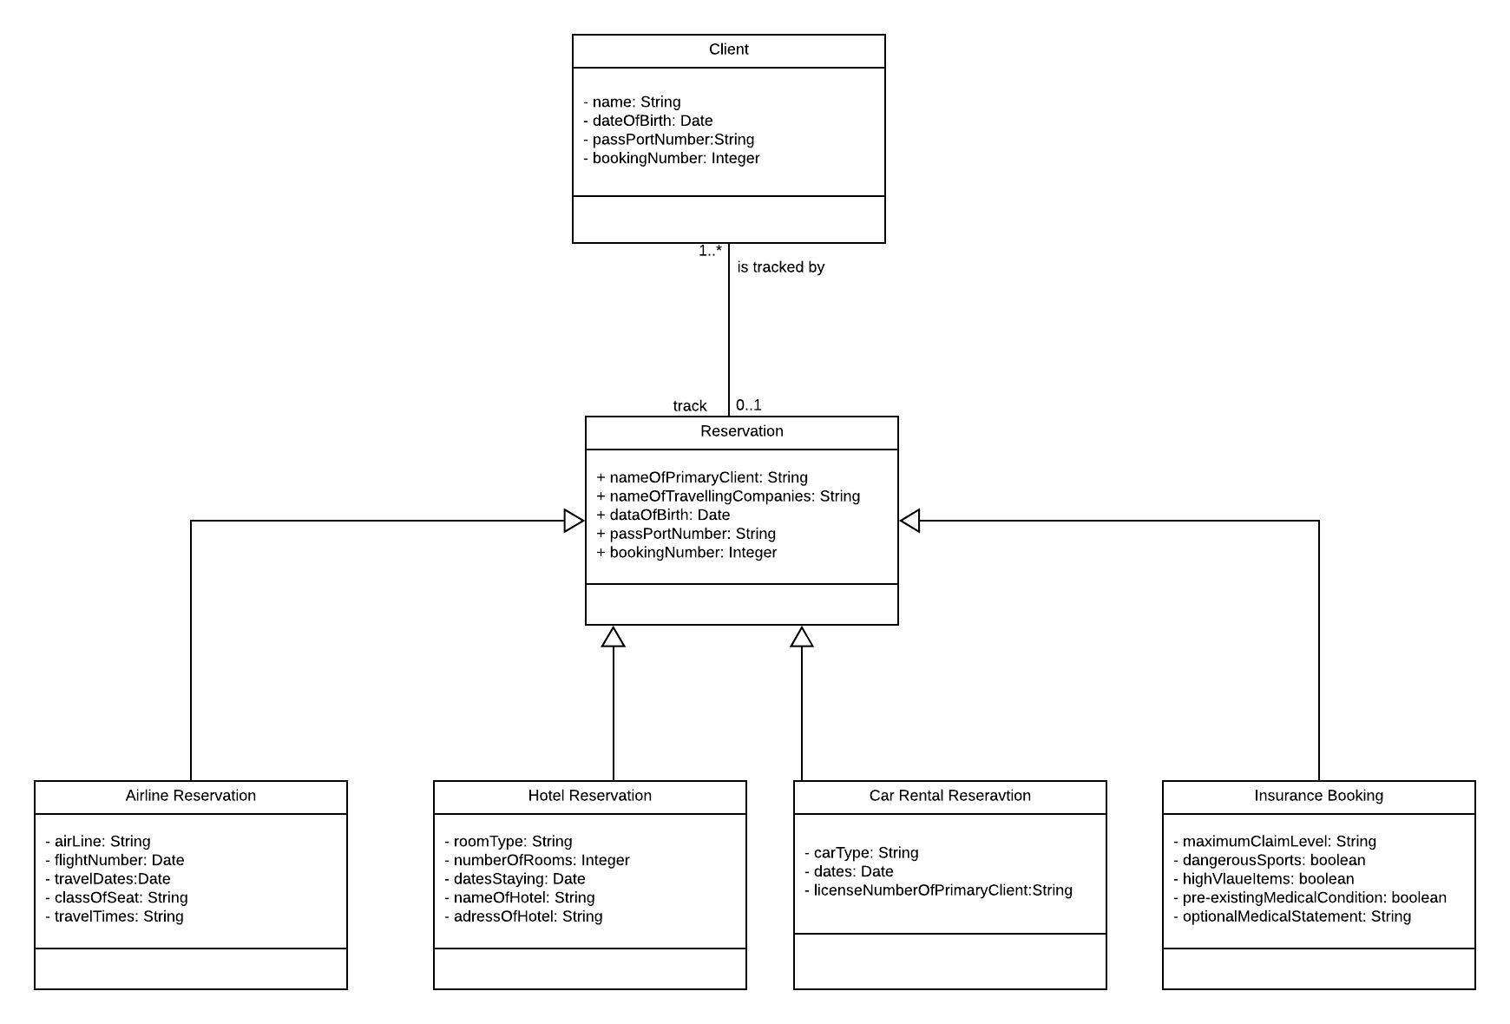

**TASK 2. (25%)** You are required to draw a UML **activity diagram** to represent the following scenario of a hairdresser’s salon.

*Customers enter the salon and wait until the next hairdresser is free. They then indicate whether they would like their hair washed first or a “dry-cut” without having their hair washed. The hairdresser washes the hair (if asked for) and then cuts it. After finishing the customer’s hair the hairdresser moves onto the next waiting customer, or waits for another one to enter the salon. The customer goes to the till and waits for a cashier to be free to take their payment. They can pay by either cash or by credit card (where they need to type their pin into the machine) and they then leave the salon.*

**SOLUTION :**

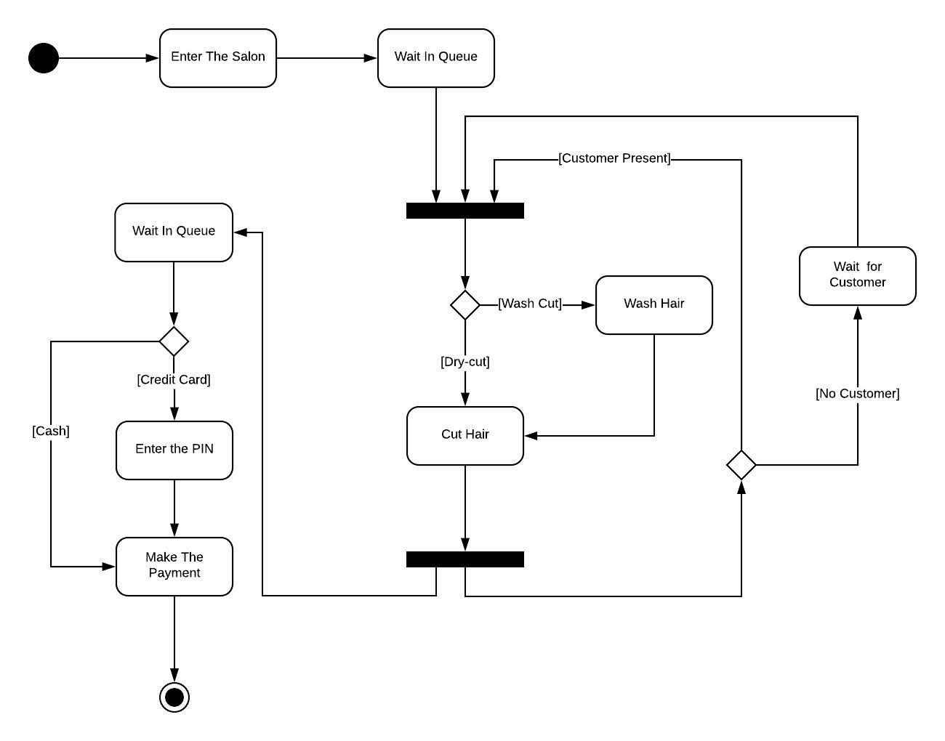

**TASK 3. (25%)** Read the following passage **carefully**.  
*An employee has a name, address, phone number, date of birth and job title. Employees can be*

*appointed and can leave, and are either monthly paid employees or weekly paid employees.*

*Monthly paid employees have a bank sort code, bank account number and number of holidays while weekly paid employees are paid in cash on a specified day of the week - their payday. Weekly paid employees may apply to be promoted to a monthly paid employee. Monthly paid employees can take a holiday if they have sufficient number of holidays remaining.*

*All employees are entitled to use the Sports Centre if they register to do so. The Sports Centre is made up of two gyms (with a maximum capacity), three tennis courts and a bar.*

*The bar can be booked for special events, and has three rates of hire - a working hours' rate, an evening rate and a weekend rate. The Sports Centre holds a list of employees who have registered.*

*An employee's age can be calculated from their date of birth, in order to prevent under-age drinking at the bar.*

You are required to draw a UML **class diagram** for the above system. All the key words you need to include are underlined – do *not* invent any details additional to those given above:

1.Illustrate the various classes that exist, with their attributes and operations (including any derived ones, represented in the usual way)

2.Mark on the relationships that exist between the classes using the standard UML symbols to represent the *type* of each relationship

3.Add multiplicities  
4. for any relationships of **association:**

1. mark on the navigability
2. appropriately name the two roles

**SOLUTION :**

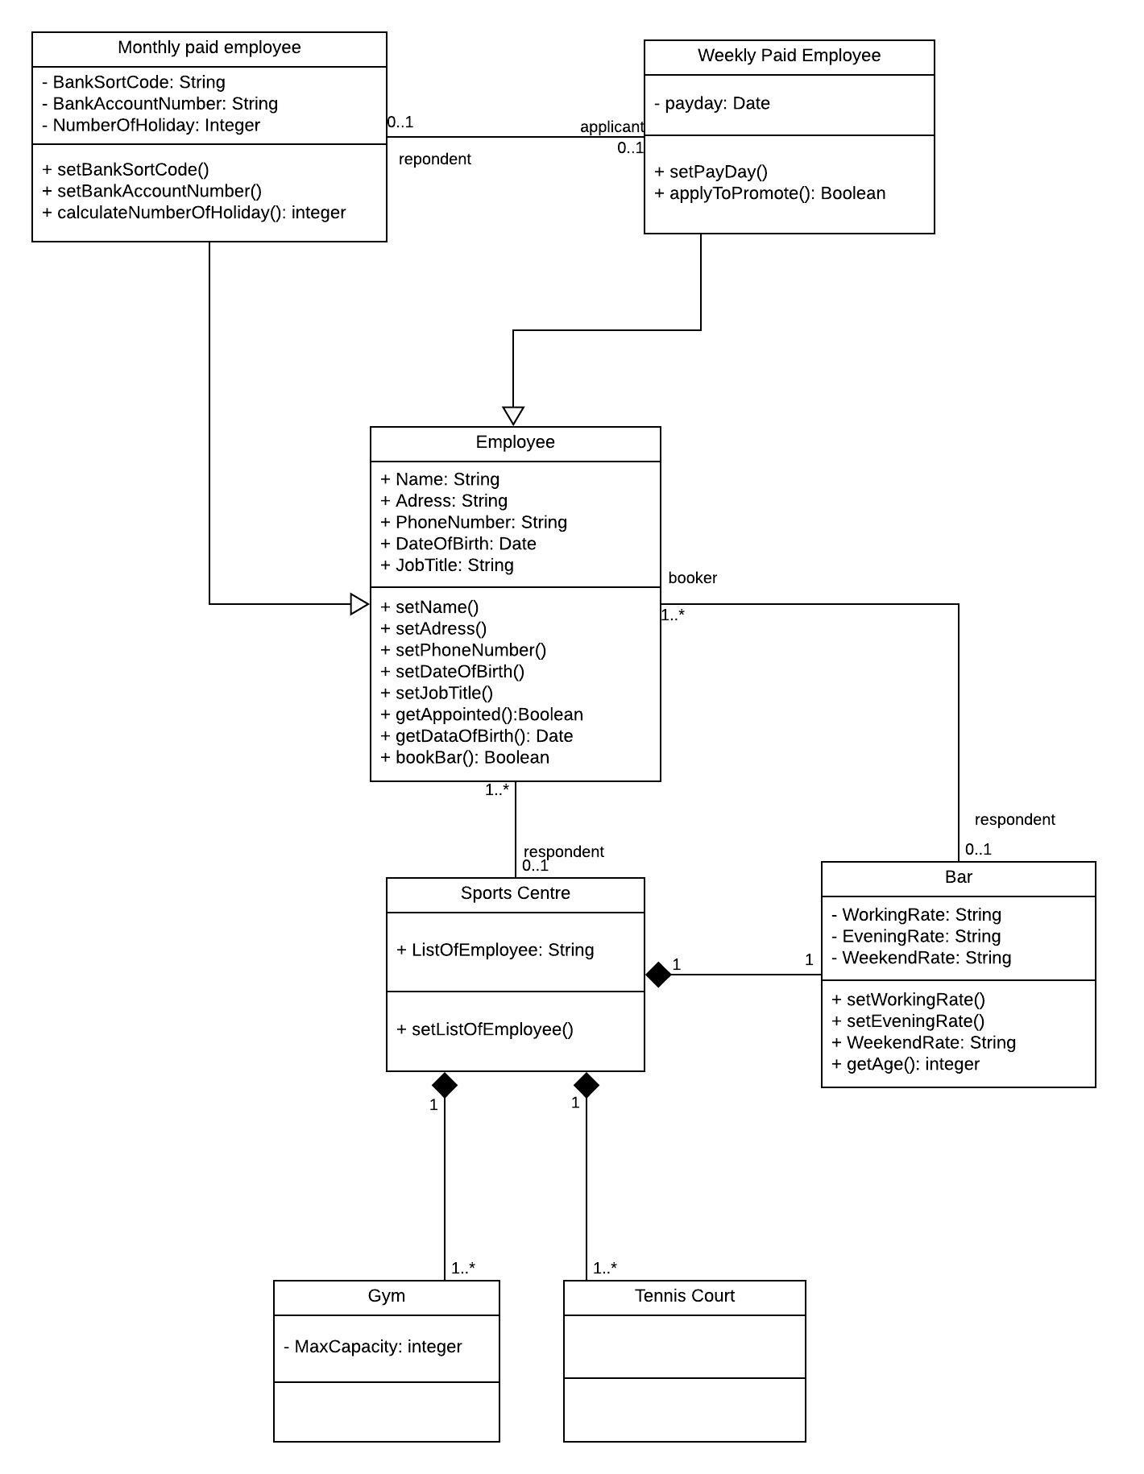

**TASK4. (25%)** Draw a UML **sequence diagram** that specifies the following protocol of initiating a two-party phone call. NOTE: ArgoUML does not fully support Sequence Diagrams, it may be better to use a different program (such as OpenOffice Draw/ Microsoft Powerpoint) or (neatly) draw the diagram by hand. Assuming that there are four objects involved:

* two Callers (s and r),
* an unnamed telephone Switch, and
* Conversation (c) between the two parties.

*The sequence begins with one Caller (s) sending a message (liftReceiver) to the Switch object. In turn, the Switch calls setDialTone on the Caller(s), and the Caller(s) iterates (7 times) on the message dialDigit to itself. The Caller(s) then sends the digits to the switch. The Switch object then calls itself with the message routeCall. It then creates a Conversation object (c), to which it delegates the rest of the work, the digits are sent to the conversation object as part of the object creation process. The Conversation object (c) sends rings to the Caller (r), who asynchronously sends the message liftReceiver back to the conversation object when the phone it picked up. The Conversation object then tells both Caller objects to connect, after which they talk. Once Caller (r) sends a disconnect message to Conversation then Conversation tells both Caller objects to disconnect and also it tells the Switch to disconnect. After that Switch deletes the object Conversation.*

All the key words you need to include are underlined – do *not* invent any details additional to those given above.

**SOLUTION :**

